Object and Lender | Image | Quirk | Info | Posting Order
Cricket Bat  Marylebone Cricket Club | 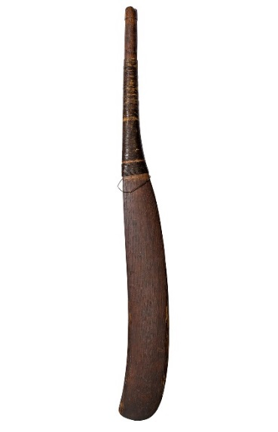 | Left-Handed | Cricket was first mentioned in 1624 and evolved into a popular spectator sport in the eighteenth century. This solid wood, left-handed bat has a twine wrapped handle and off-centre ridge on the blade. Its slightly curved blade was an advancement from early bats that were curved almost like a hockey stick, to accommodate an underarm bowling style. As the sport evolved and became more regulated, bats developed into today’s recognisable style.  Cricket as a large-scale spectator sport was essentially a creation of the eighteenth century. The game spread from its heartland in south-eastern England to become a truly national pastime: the first record of a cricket match in Yorkshire, for example, dates from 1751. Brought players together across the boundaries of social class: both the gentry and common people took part. Cricket matches usually took place on common land, village greens or open moor, and were thus open to common view, often attracting large and unruly crowds. | Could post to correspond with an England game. Playing on 24, 27 and 30 Aug, 1,4, and 7 of Sep, 12 Oct and 9 Nov.

Print showing a Ladies cricket match  Marylebone Cricket Club | 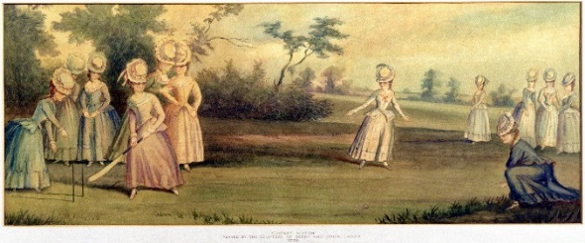 | Ladies cricket match with Countess of Derby  Evidence of early underarm bowling | This remarkable image most likely depicts an informal match amongst friends, but women’s cricket matches were often spectator events, drawing large crowds and heavy betting, as in men’s cricket. The underarm bowling technique of the early game is evident by the hand position of the bowler in the right foreground of the image.  Whilst cricket sometimes received generous support of noble patrons, who financed teams and matches, a central element in its growth and increasing appeal was gambling.  Lady Derby was popular in the beau monde and her actions garnered significant press attention. Along with the Duchess of Devonshire, she was considered a leader of fashion. In 1777, she organised a cricket match in which the two teams were populated with upper-class women.  Lady Derby very famous for having an affair. | Could post to correspond with an England game. Playing on 24, 27 and 30 Aug, 1,4, and 7 of Sep, 12 Oct and 9 Nov.
Playbill – Handel’s Messiah  Bath Library Services | 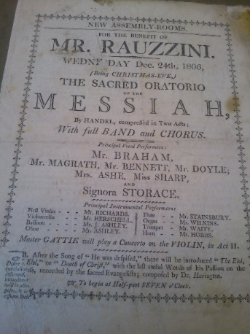 | Playbill has been hand annotated with thought about the performance – takes place in York | Venanzio Rauzzini was an Italian castrato, composer, pianist, singing teacher and concert impresario. Rauzzini performed throughout Europe and had a very successful career in London from 1774 until his retirement from the stage in 1778. He moved to Bath in 1780 where he became Director of the New Assembly Room Concerts until his death in 1810. Bath’s concerts reached their peak of excellence under Rauzzini and the city's music became internationally renowned.  Music was a pleasurable leisure and communal activity in the Georgian era, enjoyed across the social spectrum. Professional music-making was increasingly performed at venues such as opera houses, assembly rooms, pleasure gardens, taverns, churches and the theatre.  The eighteenth century also saw an explosion in enthusiasm for opera, in large part due to Handel. In the early eighteenth century opera was dominated by castratos. The most famous castrato was Farinelli who could hold a note for a whole minute and sing over three octaves. Castratos could also demand vast sums of money to perform. Senesino, who was persuaded by Handel to perform in London in 1710, commanded £2000 for the year.  York, in particular, could boast an impressive programme of events, with musical performances at the Assembly Rooms, and concerts, such as Handel’s Messiah, at the Minster.
Kitty Bridges’ Notebook  English Folk Dance and Song Society, Vaughan Williams Memorial Library | 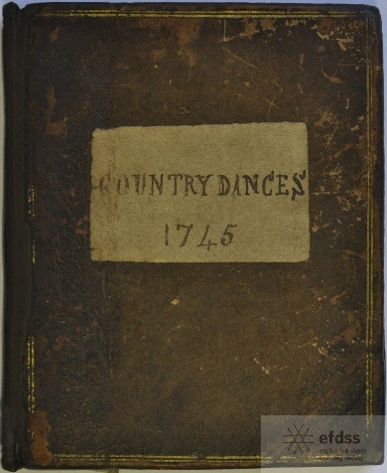 | Handwritten collection of favourite dances – interesting titles of dances | Kitty’s Bridges’ notebook includes a personally selected and handwritten collection of her favourite country dances. Dances include ‘The Cooler’, ‘Just a going’ and ‘Ne’re a Bottom’. Each page includes the musical score for the dance and instructions on how to perform it correctly.  Dancing was widely enjoyed throughout the eighteenth century. Dancing was an opportunity to display, to highlight one’s graceful manners, deportment and refined taste. Indeed, in a society where an inability to dance was associated with vulgarity, rusticity and bad manners, and where the scrutiny of the crowd could be intense, it is unsurprising that many of the wealthiest employed dance instructors. Dance masters taught technique - the execution of the minuet and formal dances, English county dances in all their variations, the modish cotillion and late-century favourites such as the Scottish and Irish steps. They also offered instruction on etiquette and the cultivation of polished manners.  Dancing was constantly evolving in the period, with a succession of new dances being invented each year. For those without a dancing master to keep pace, small pamphlets or ladies pocket books were published which described the steps and sometimes printed the appropriate tunes. Whilst dancing was enjoyed by all classes, there was clearly a hierarchy when it came to the types of dance being performed. The minuet was considered to be the court dance par excellence and took pride of place at dress balls throughout the century. In comparison country dances, which were performed in parallel lines, were considered to be more social and less elitist. Indeed, the gregarious and energetic nature of many county dances, coupled with the close physical contact they required, meant they often incurred the disapproval of prudes.
Print of race between Mrs Thornton and Mr Flint  York Museums Trust | 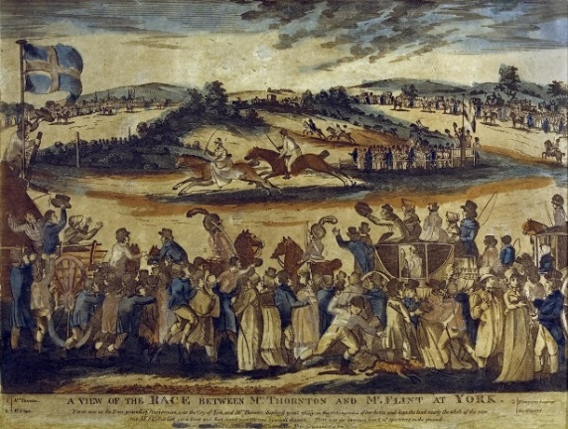 | Famous race at York, 100,000 spectators.  Female jockey | Image depicting the race between Mrs Alicia Thornton and her brother-in-law Captain Flint, which took place on the 25th August 1804 at York Race course. Nearly 100,000 people came to watch this unusual match, in which Mrs Thornton ‘displayed great ability in the management of her horse and kept the lead nearly the whole race’. Thornton lost by a small distance.  Horse racing offered the irresistible combination of the thrill of the race, the highs and lows of gambling. Horses were invariably owned by members of the aristocracy or gentry, the prestige of winning often being more important than the value of the prize. Spectators would gamble furiously on races, bets being conducted between individuals at the ‘betting post’ – bookmakers did not emerge until towards the end of the eighteenth century. In a bid to further entice audiences, and crucially bring the wealthy gentry to town, race days would often coincide with Assizes.
Racing Calendar  Borthwick, University of York and York Racecourse | 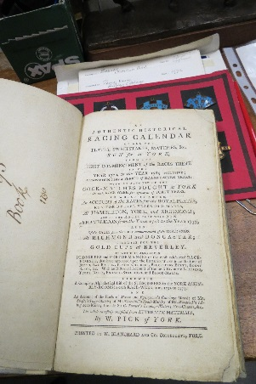 | List of Subscribers to the Assembly rooms Included – lists the name of the Fairfaxes, one of the only years they subscribed | Pick’s volume records the results of all the races run at York between 1706 and 1785. It also includes details about cock-fighting matches fought in York, which stresses the appeal and importance once attached to this blood sport. The calendar also includes a list of subscribers to the Assembly Rooms.  York has a long tradition of horse racing. Land offered by Sir William Robson on Clifton and Rawcliff Ings approved for a course. Racing on the Knavesmire began 16 August 1731 with a new six day meet on a brand new course. 1755 – Grandstand designed by John Carr was built – Fairfaxes sponsored the building  Public assemblies often took place during race week – places to see and be seen. Here the social elite enjoyed gatherings, games, refreshments and dancing for the price of a seasonal or annual subscription. The building of the new Assembly Rooms in the 1730s coincided with the move of the racecourse to the Knavesmire. Francis Drake declared ‘here it is that York shines indeed, when… four or five hundred of both sexes, out of the best families in the kingdom are all met together … the politeness of the gentlemen, the richness of the dress, and the remarkable beauty of the ladies, and, of late, the magnificence of the room they meet in, cannot be equalled, throughout, in any part of Europe.’ | Week 1
Wallas’ Comic Cards  Dede Scott Brown (York Racecourse) | 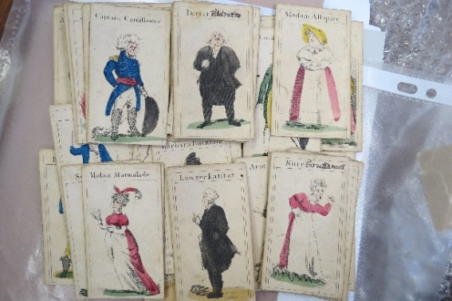 | Children’s hand painted cards with amusing character names | This pack of children’s hand painting ‘comic cards’ includes amusing characters such as ‘Simon Sober’, ‘Dame Dowdy’, ‘Tabitha Transparent’ and ‘Bully Bounce’. Little is known about how this particular game was played though it certainly seems to have a moralising tone through the use of droll stereotypical characters.
Lottery Office Image  Valerie Jackson Harris | 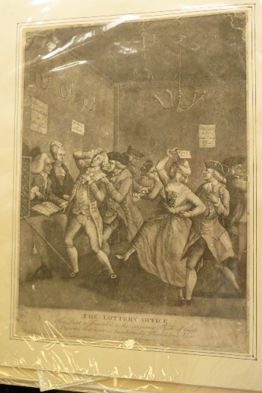 | Potential winnings of £30,000 – can link this to a modern lottery draw | This satirical image depicts the interior of the ‘State Lottery Offices’ of Sharp & Co. A poster on the wall advertises the potential winnings, claiming ‘£30,000 for one shilling at this office’. Lottery offices issued lottery loans, in which investors bought bonds whose size was determined by a draw. The probability distribution of these draws was perfectly known and highly skewed. After the draw the bonds were indistinguishable from other bonds.
Theatre Playbill  Borthwick and University of York | 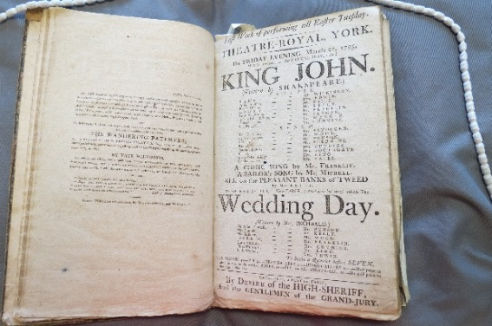 | Performances taking place at York Theatre Royal – Mention of Sarah Siddons | This book includes playbills for the Theatre Royal, York, with performances ranging from pantomimes to Shakespeare. Along with ‘King John’, this page also includes ‘The Wedding Day’, a farce by Elizabeth Inchbald.  The eighteenth century saw the flourishing of theatre as a popular pastime. York could boast a long established theatre tradition, from ‘strolling-players’ who performed productions at St Anthony’s Hall and later at Market Hall, to Thomas Keregan’s company who performed at Lord Ingram’s mansion in Minster Yard and, from 1744, at the Theatre Royal. Whilst theatre had always been a key component of York’s entertainment scene, under the stewardship of Tate Wilkinson from 1766, the Theatre Royal enjoyed national recognition for its productions and received a royal patent in 1769.  The theatre attracted a wide range of social classes and economic groups. Dramatists were highly conscious of the need to appeal simultaneously to the different constituencies that populated pit, boxes and galleries. As such, theatres would provide a whole evening of entertainment, a bill usually consisting of a main piece, either a comedy or a tragedy, followed by a short afterpiece, which was usually a farce. In addition there could also be musical, dance or variety acts, some of which may even have occurred between the acts of the main play.
Snuff Box  University of St Andrews | 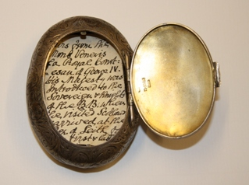 | Supposed to contain the pubic hair of one of George IV mistresses | This snuff box contains, according to the note kept in it, the pubic hair of one of George IV’s mistresses, presented to the Beggar’s Benison Club by the King when he visiting Edinburgh in 1822.
Good Humour Club Minute Book  Laurence Sterne Trust |  | York based men’s society. Book records each meeting names of those members who attended and those who were issued with a small fine for failure to attend. | The Good Humour Club, founded c.1725, was a York based society that celebrated the virtues of companionship and conviviality. Members were men who belonged to polite trades and professions including clergymen, doctors, masons and drapers. They would meet weekly at Sunton’s Coffee-House on Coney Street and consume copious amounts of good food and drink. This minute book records matters arising at each meeting, as well as the names of those members who attended each week and those who were issued with a small fine for their failure to attend.  From 1732 to 1836 ‘The Most Ancient and Most Puissant order of the Beggar’s Benison and Merryland, Anstruther’, known as the ‘The Beggar’s Benison Club’ sought to reinforce the bonds of homo-sociability through a celebration of male sexuality. The club spawned branches in Glasgow, Edinburgh and even St Petersburg. Early members were local merchants and the gentry, though later recruits included members of the upper ranks of society, including the Prince of Wales (later George IV). Using myths and pseudo facts to justify their foundation the club employed a series of obscene rituals awarding a mock-solemn ‘diploma’ to their ‘knights’ so that they may freely enjoy ‘Merryland’ – a euphemism for sex.  The hedonistic club revelled in their sexuality and conducted a series of surprising initiation ceremonies including masturbating in front of existing members. Other unusual activities included comparing phalluses, studying the genitalia of ‘posture’ models, listening to lectures on sex and collectively masturbating leaving deposits in a ‘Test Platter’ for examination.  The Beggar’s Benison Club was not unique in its preoccupation with sex and the female body. The various incarnations of the ‘Hell Fire Club’, the Wig Club and even the Society of the Dilettanti had, what perhaps seems today, to be an adolescent fascination with rakish behaviour. Yet despite sharing such licentious pre-occupations, it is clear that what these clubs, like many others in the period, also offered was a space for sociability and conviviality, where interests could be shared and friendships formed.
Ballooning Article/Balloon-mania  Various |  |  | These momentous aerial events were widely reported and excited huge interest, not least in Britain. The first person to take a balloon flight in the British Isles was James Tytler, a Scottish apothecary who had become fascinated by ballooning. Inspired by the Montgolfiers’ achievements, Tytler constructed a ‘Fire Balloon’ which successfully took flight over Edinburgh, with himself as passenger, on 27 August 1784.  This first British hot air balloon flight was followed less than three weeks later by the better-known ascent of Vincenzo Lunardi. On 23 August 1786 Lunardi came to York with his balloon. Cheered on by a great assembly of onlookers, he took off from an orchard near the Minster, rose to a ‘prodigious height’, and rapidly disappeared from sight in an easterly direction. He encountered hail, rain, snow, and an electrical storm on his flight, but eventually landed, safely but ‘quite benumbed with cold’, at Kilnwick Percy near Pocklington, twelve miles from York.  The writer Horace Walpole coined the term ‘Balloonomania’ to describe the huge popular enthusiasm for ballooning that swept the country in response to such exploits. Songs were written about ballooning, the exploits of balloonists were reported in the press and illustrated in prints and cartoons, ballooning appeared in poetry and fiction, and ladies sported skirts and bonnets designed to resemble balloons. In Britain it was an exercise in entertainment dominated by daredevils seeking fame and fortune.
Mother Shipton Puppet  University of Bristol, Theatre Collection | 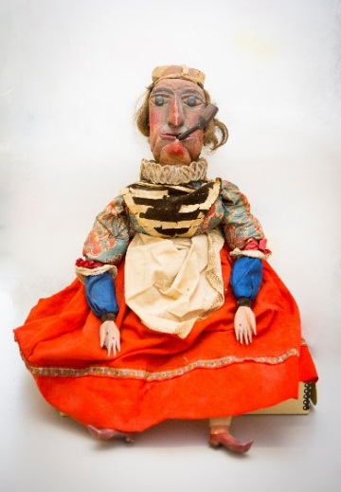 | Famous british soothsayer – legendary ugly looks and behind today’s ugly witch stereotype. Born in a cave in Knaresborough. | This puppet of the famous British soothsayer Mother Shipton, shows her legendary ugly looks. Born in a cave on the River Nidd, she was said to have had a large nose, crooked back, and twisted legs. Along with puppet shows, the character of Mother Shipton was common in early pantomime. She is also credited as the inspiration behind today’s ‘ugly witch’ stereotype.
Frost Fairs Print  Darrell Buttery |  | Printed on the ice itself – possibly set up printing press | Frost Fairs in York were semi regular events which took place on the Ouse near Ouse Bridge every time the river froze. Here Georgians in search of entertainment could experience a plethora of activities, including ice skating which is shown in this early print. This engraving was ‘PRINTED on the Ice’ suggesting some ingenuity in setting up a printing press on the ice. The inscription at the bottom of the print reads ‘I pray to God that one soul may not perish, thou the Ouse is frozen, may the city flourish’. The last Frost Fair took place in the early nineteenth century before Old Ouse Bridge was knocked down.  The excitement of the fairground, with its diverse attractions and spectacles, refreshment stands and hundreds of stalls, saw a cross section of society join together to be entertained, including the royal family who attended St Bartholomew’s fair every year between 1714 and the 1740s.  Fairs owed part of their appeal to their timing in August and September when the theatres were closed for the summer, or during traditional holidays. Fairs could last up to two weeks, though towards the end of the century this shortened to around three days. The plethora of entertainments available was often staggering in scope and could range from shows offering farces, shortened plays, biblical tales, puppet and harlequin shows, human and animal oddities, scientific curiosities, contortionists and acrobats.  St Bartholomew’s Fair was the most important fair in London, held in Smithfield on the northern edge of the city and attracting thousands of visitors each year.
York Gold Cup  Fairfax House | 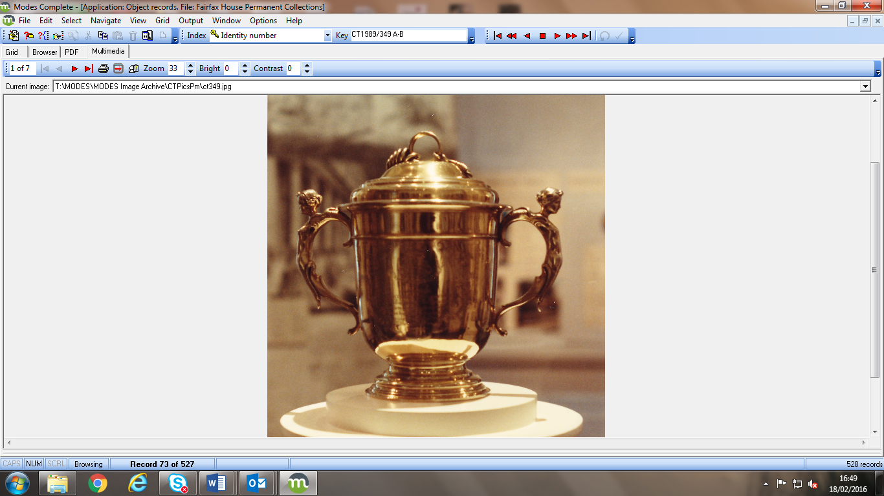 | Given by Queen Anne, won following a race on Clifton Ings | This exquisite gold cup was given by Queen Anne as a prize for racing in York. It was won outright by Mr Greame’s horse ‘Champion’ in August 1713, following a race on Clifton Ings. The cup is engraved on the front with the Royal Coat of Arms and on the reverse with a galloping horse and jockey. The cup is inscribed with the following: ‘This Plate Run for at York by Six Year Old Horse August 3rd 1713’.  Horses were invariably owned by members of the aristocracy or gentry and races were run for gold or silver cups – the prestige of winning often being more important that the value of the prize.
The Queen’s Female Zebra  Valerie Jackson Harris | 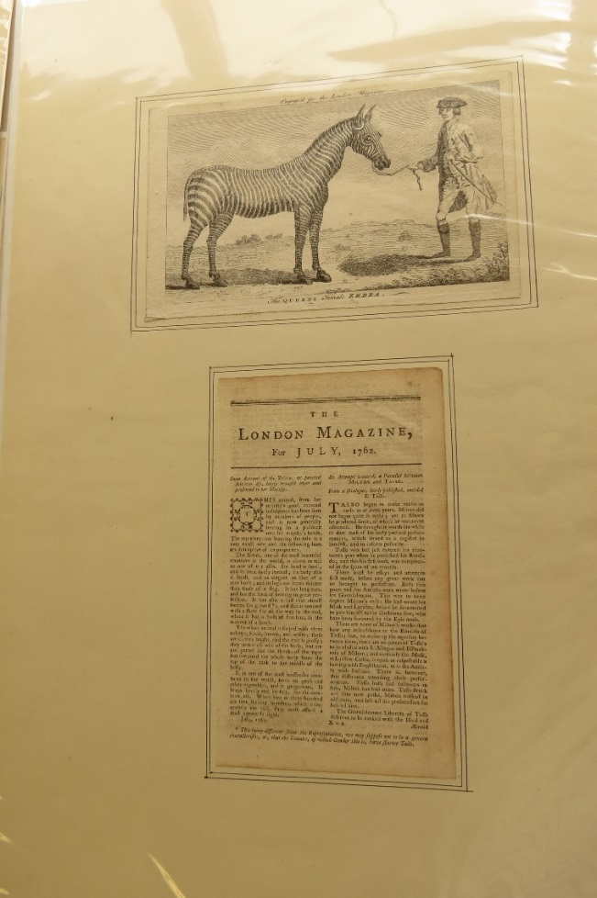 | Zebra presented to Queen Charlotte, often seen grazing near her house | This illustration accompanied the ‘Account of the Zebra’ published in the London Magazine, and was said to be a ‘very exact’ representation. This tame zebra, held by a halter, was presented to Queen Charlotte and was often seen grazing near her house.  The eighteenth century was a time of imperial expansion and global exploration, and this aspect of the age was reflected in the travelling menageries which brought exotic creatures from around the world to the towns and cities of Georgian Britain, including York. The business of operating menageries was highly commercial and competitive. Menagerie owners advertised extensively in advance of their arrival in particular towns and, in order to maximise interest and their profits, planned their shows to coincide with fairs and race days.  A visit to London might also involve a visit to Buckingham Gate to see Queen Charlotte’s two zebras. A visit to Buckingham Gate was supposed to be free, but guards often charged for the privilege of viewing ‘the Queen’s ass’. When the first zebra died she was stuffed and placed on display at the Blue Boar Inn on Castlegate, York – where, unfortunately for the Queen, the joke endured.
Cribb and Molineaux Fight  Phil Whiteoak | 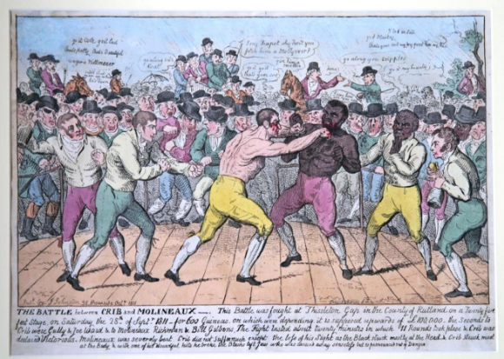 | 20,000 Spectators  Molineaux as a form of exotica? | The fight between Cribb and Molineaux at Thistleton Gap in 1811 was watched by a crowd of 20,000 spectators. Thistleton Gap was picked because it was close to three county borders and out of the jurisdiction of any magistrates, so the crowd could hastily flee if the match was closed by the authorities. The crowd watched as Cribb emerged victorious and Molineaux was carried from the ring, bloodied and beaten.  There were few large scale boxing matches organised in York in the period, though the city could boast its very own boxing legend in the form of Bill Richmond. Richmond was born to enslaved Georgia-native parents in 1763 on Staten Island, New York. A British officer in New York City took him under his wing and sent him to school in Yorkshire, later apprenticing him to a cabinet maker in York. Richmond became a professional boxer when he moved to London around 1804 and went on to a series of victories. Richmond also trained another former slave and future famous boxer Tom Molineaux, whose fight with Tom Cribb in 1810 drew crowds of over 20,000 people.  Born into slavery in Virginia, Molineaux was trained by his father, also a fighter, as was Molineaux's twin brother. He boxed with other slaves to entertain plantation owners. Molineaux earned his owner a large sum of money in winnings on bets, was granted his freedom, and moved to England where he expected to be able to earn money as a professional boxer.  On 3 December 1810, having been trained by Bill Richmond, another ex-slave turned boxer, Molineaux fought Tom Cribb at Shenington Hollow in Oxfordshire for the English title. According to Pierce Egan, Molineaux stood five foot eight and a quarter inches tall, and for this fight weighed "fourteen stone two". Egan wrote that few people, including Cribb, expected the fight to last very long; there was betting that Cribb would win in the first ten rounds. There was a disturbance in the 19th round as Molineaux and Cribb were locked in a wrestler's hold. The referee stood by, uncertain as to whether he should break the two apart, and the dissatisfied crowd pushed into the ring. In the confusion Molineaux hurt his left hand; Egan could not tell if it had been broken.^{[2]} There was also dispute over whether Cribb had managed to return to the line before the allowed 30 seconds had passed. If he had not, Molineaux would have won, but in the confusion the referee could not tell and the fight went on. After the 34th round Molineaux said he could not continue^{[2]} but his second persuaded him to return to the ring, where he was defeated in the 35th round.  The return fight on 28 September 1811 at Thistleton Gap in Rutland was watched by 15,000 people. Egan, who was present, said that both fighters "weighed less by more than a stone",^{[2]} which means Molineaux weighed at most 185 pounds for this fight. Molineaux, though still hitting Cribb with great power, was out-fought; Cribb broke his jaw and finally knocked him out in the 11th round.^{[2]} After the fight Richmond and Molineaux parted.  Molineaux's fight with Cribb was turned into a 2014 play called Prize Fighters, by Ed Viney. | Maybe tie in with Olympic boxing event?
Silver Admission Ticket  The Garrick Club | 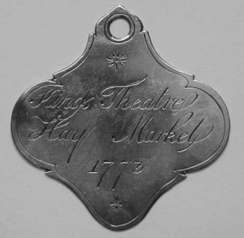 | Inscribed with Garrick’s name, for Haymarket Theatre in London | Silver admission ticket belonging to David Garrick for the Haymarket Theatre, London. It is inscribed on the reverse with Garrick’s name.  The Garrick Club is one of the oldest, highly esteemed and exclusive members club in the world and since its conception has catered to members such as Charles Kean,Henry Irving, Laurence Olivier, Charles Dickens, H. G. Wells, J. M. Barrie, A. A. Milne, and Kingsley Amis.  The Club was named in honour of the eminent actor David Garrick, whose acting and management at the Theatre Royal, Drury Lane in the previous century, had by the 1830s come to represent a golden age of British drama.
Merlin’s Book – Weight Book  Harrogate Museums and Arts | 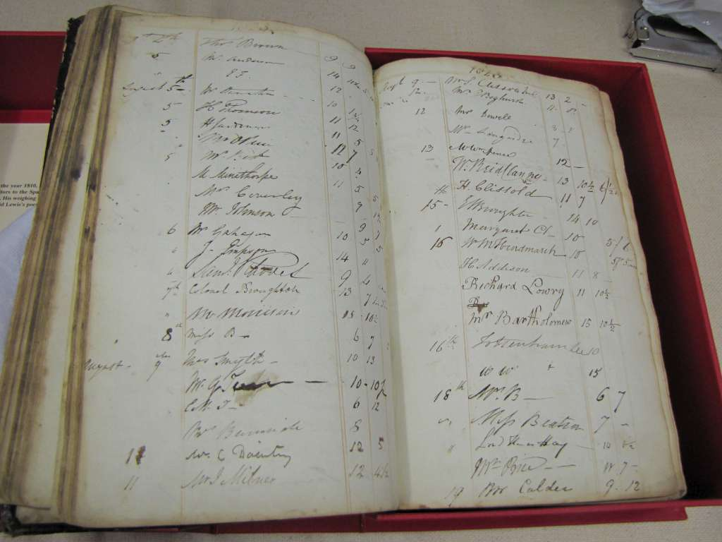 | Georgian fascination with weight – tracks weight loss as a result of spa treatments | In a culture where size mattered, and difference was considered to be a spectacle, this extraordinary book vividly highlights the Georgians’ fascination with their own weight. It tracks weight loss as a result of spa treatments by recording weight before and after taking the waters. The book was kept by a Harrogate shopkeeper and subsequently taken on by people after him.  Could we include the article about visiting baths and spas?
Dancing Dogs Article  York Explore? |  | Can link this to the dancing dogs who’ve won BGT?  Not such a modern notion
Astley’s Ampitheatre  Valerie Jackson Harris | 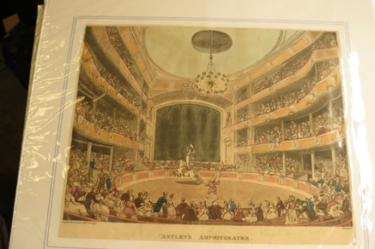 | Rowdy well-dressed bunch. Credited with invention of modern day circus | Philip Astley has been credited with the invention of the modern day circus. Originally opened as a riding school, from 1770 Astley was entertaining crowds with displays by acrobats, jugglers and clowns. Circuses like Astley’s were in many ways developed out of the theatre tradition, mirroring the variety of acts and use of space.  Despite the wealth of entertainments provided, theatre audiences could often be rude, noisy and dangerous. Alcohol and food was consumed in great quantity, while people frequently arrived and left throughout the duration of the performance. Audiences chatted amongst themselves and sometimes pelted actors with rotten fruit and vegetables. James Boswell described mooing like a cow during one particularly bad play, to the great amusement of his companions. Rioting at theatres was also not uncommon. The Drury Lane theatre in London, for example, was destroyed by rioting on six occasions during the century.
Ivory Dildo  The Science Museum | 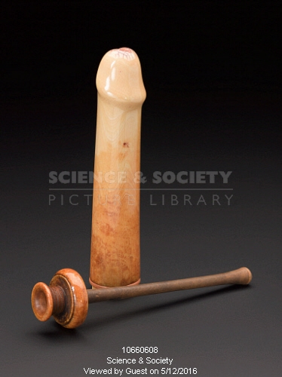 | Discovered in a convent, made from ivory | This exceptional eighteenth century ivory dildo, in the form of an erect penis, includes a pump to simulate ejaculation. Found in a convent in Paris, hidden for almost a hundred years in the seat of a Louis XV armchair, it comes with its own cloth bag. The exceptional quality of this dildo and the use of fine materials clearly distinguishes it from the more common leather dildo of the period, which was moulded into shape using old rags. Indeed, it is likely that this dildo belonged to a lady of considerable wealth. Though not as visible in society as male pleasurable pursuits, this dildo nonetheless highlights the access some women in the Georgian era had to erotica and sex toys.
Animal Gut Condom  Thackray Medical Museum | 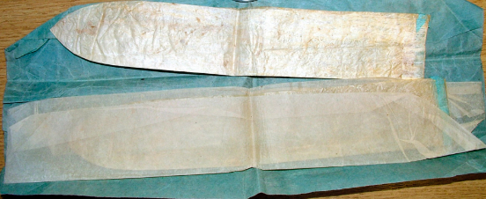 | Made from animal guts with a blue silk ribbon | Commonly found in brothels, though also domestically, animal gut condoms were mainly used to prevent the spread of sexually transmitted diseases, such as syphilis. As in this example, they were secured in place at the top by silk ties. Condoms were extremely delicate and difficult to manufacture which made them an expensive luxury. Because of this most were washed after use and reused.
Something from public hangings?  Noose  Lancaster Museums | 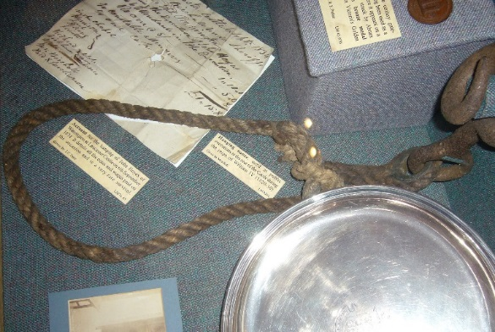 | Popular entertainment – nooses sometimes split up and sold as souvenirs | Hanging noose used for public executions held at the rear of Lancaster Castle during the reign of William IV. With executions on the rise in the late-eighteenth century, public hangings drew huge crowds. They were so popular that they were called ‘hanging fairs’ and there were over one hundred nicknames for the gallows.
Trial of Dick Turpin  Borthwick | 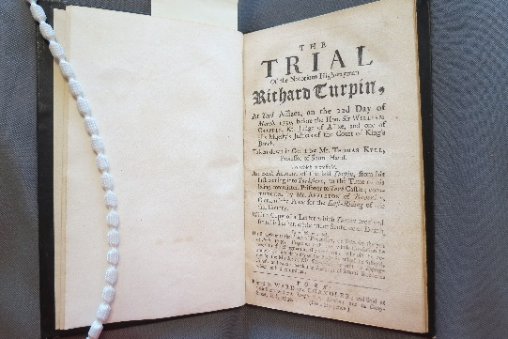 | Local legend – well known | This publication describes the famous trial of the highwayman Dick Turpin which took place at York Assizes. Taken from local resident Thomas Kyll’s recordings of the trial, it offers a word for word account of proceedings. The book also includes records of Turpin’s life in his ‘own words’, from his time in Yorkshire to his imprisonment in York Castle. Following his trial Turpin was found guilty and sentenced to death. He was hung at ‘York Tyburn’ on the Knavesmire in York on 7 April 1739.
Drinking Glass  St Andrews | 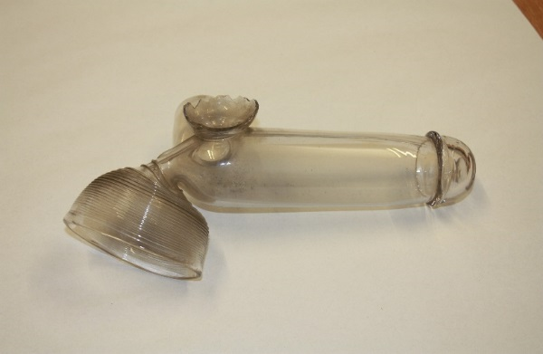 | Novelty shaped drinking glass | Wine would dribble down the front of the shirt when new members of the Beggar’s Benison used this phallic-shaped ‘prick glass’. Along with drinking, members would have enjoyed pursuits such as listening to lectures on sex and anatomy, perusing pornography and watching and examining nude ‘posture’ models during meetings

